https://www.electronicwings.com/raspberry-pi/mpu6050-accelerometergyroscope-interfacing-with-raspberry-pi

MPU6050 (Accelerometer+Gyroscope) Interfacing with Raspberry Pi

Introduction
- MPU6050 sensor module is an integrated 6-axis Motion tracking device.
- It has a 3-axis Gyroscope, 3-axis Accelerometer, Digital Motion Processor and a Temperature sensor, all in a single IC.
- It can accept inputs from other sensors like 3-axis magnetometer or pressure sensor using its Auxiliary I2C bus.
- If external 3-axis magnetometer is connected, it can provide complete 9-axis Motion Fusion output.
- A microcontroller can communicate with this module using I2C communication protocol. Various parameters can be found by reading values from addresses of certain registers using I2C communication.
- Gyroscope and accelerometer reading along X, Y and Z axes are available in 2’s complement form.
- Gyroscope readings are in degrees per second (dps) unit; Accelerometer readings are in g unit.
For more information about MPU6050 Sensor Module and how to use it, refer the topic MPU6050 Sensor Module in the sensors and modules section.
To interface MPU6050 using Raspberry Pi, we should ensure that I2C protocol on Raspberry Pi is turned on. So before going for interfacing MPU6050 with raspberry Pi, we need to make some I2C configurations on Raspberry Pi which you can refer Raspberry Pi I2C.
After configuring I2C on Raspberry Pi, let’s interface Raspberry Pi with MPU6050.

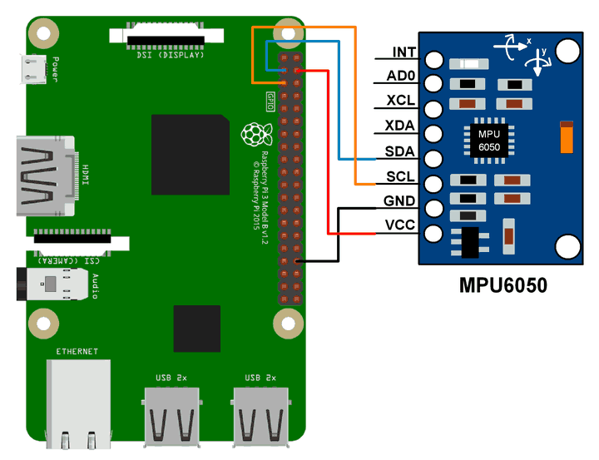
Example
Here, we will interface MPU6050 module with Raspberry Pi to read Gyroscope and Accelerometer value and print them.
We can interface MPU6050 module with Raspberry Pi using Python and C language. We will display the value of Accelerometer and Gyroscope on terminal which are read from MPU6050 module.
For frequently used Python based I2C function on Raspberry Pi you can refer Python based I2C functions for Raspberry Pi.

Python Program
'''
Read Gyro and Accelerometer by Interfacing Raspberry Pi with MPU6050 using Python
http://www.electronicwings.com
'''
import smbus #import SMBus module of I2C
from time import sleep #import

#some MPU6050 Registers and their Address
PWR_MGMT_1 = 0x6B
SMPLRT_DIV = 0x19
CONFIG = 0x1A
GYRO_CONFIG = 0x1B
INT_ENABLE = 0x38
ACCEL_XOUT_H = 0x3B
ACCEL_YOUT_H = 0x3D
ACCEL_ZOUT_H = 0x3F
GYRO_XOUT_H = 0x43
GYRO_YOUT_H = 0x45
GYRO_ZOUT_H = 0x47

def MPU_Init():
#write to sample rate register
bus.write_byte_data(Device_Address, SMPLRT_DIV, 7)

#Write to power management register
bus.write_byte_data(Device_Address, PWR_MGMT_1, 1)

#Write to Configuration register
bus.write_byte_data(Device_Address, CONFIG, 0)

#Write to Gyro configuration register
bus.write_byte_data(Device_Address, GYRO_CONFIG, 24)

#Write to interrupt enable register
bus.write_byte_data(Device_Address, INT_ENABLE, 1)

def read_raw_data(addr):
#Accelero and Gyro value are 16-bit
high = bus.read_byte_data(Device_Address, addr)
low = bus.read_byte_data(Device_Address, addr+1)

#concatenate higher and lower value
value = ((high << 8) | low)

#to get signed value from mpu6050
if(value > 32768):
value = value - 65536
return value

bus = smbus.SMBus(1) # or bus = smbus.SMBus(0) for older version boards
Device_Address = 0x68 # MPU6050 device address

MPU_Init()

print (" Reading Data of Gyroscope and Accelerometer")

while True:

#Read Accelerometer raw value
acc_x = read_raw_data(ACCEL_XOUT_H)
acc_y = read_raw_data(ACCEL_YOUT_H)
acc_z = read_raw_data(ACCEL_ZOUT_H)

#Read Gyroscope raw value
gyro_x = read_raw_data(GYRO_XOUT_H)
gyro_y = read_raw_data(GYRO_YOUT_H)
gyro_z = read_raw_data(GYRO_ZOUT_H)

#Full scale range +/- 250 degree/C as per sensitivity scale factor
Ax = acc_x/16384.0
Ay = acc_y/16384.0
Az = acc_z/16384.0

Gx = gyro_x/131.0
Gy = gyro_y/131.0
Gz = gyro_z/131.0

print ("Gx=%.2f" %Gx, u'\u00b0'+ "/s", "\tGy=%.2f" %Gy, u'\u00b0'+ "/s", "\tGz=%.2f" %Gz, u'\u00b0'+ "/s", "\tAx=%.2f g" %Ax, "\tAy=%.2f g" %Ay, "\tAz=%.2f g" %Az)
sleep(1)

https://www.instructables.com/MuscleCom-Muscle-Controlled-Interface/
MuscleCom offers a new an innovative way for physically disabled patients to communicate like never before. By measuring EMG values from a person's muscles, the user can control a user interface that will help them communicate on a day to day basis. Through the use of relatively cheap and durable components, we have developed a low-cost and easy to use product/prototype with a low learning curve.
The hardware prototype is based on a Raspberry Pi 3 Model B in a 3D printed enclosure that is running a NodeJS server with a REACT frontend that synchronizes the pulses from the users' muscles.
An example of people that could make use of this product are ALS patients and likewise. People that are able to control a (few) muscle(s) but not able to talk or point. This device is a simple to use interface that gives the patient more independence and more fun.

Stepper Motor Interfacing with Raspberry Pi

https://www.electronicwings.com/raspberry-pi/stepper-motor-interfacing-with-raspberry-pi#:~:text=Only%20four%20wires%20are%20required,Raspberry%20Pi%20using%20Python%20language.
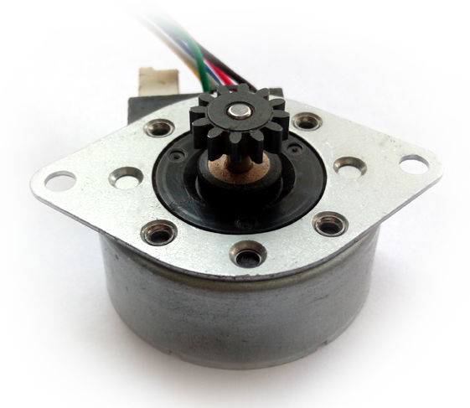
- Stepper motor is a brushless DC motor that divides the full rotation angle of 360° into number of equal steps.
- The motor is rotated by applying certain sequence of control signals. The speed of rotation can be changed by changing the rate at which the control signals are applied.
- For more information about Stepper Motor, its control sequence and how to use it, refer the topic Stepper Motor in the sensors and modules section.
- Raspberry Pi’s GPIOs can be used to control stepper motor rotation. We can generate sequence of control signals on the GPIO pins of Raspberry Pi. To know more about Raspberry Pi GPIO refer Raspberry Pi GPIO Access.
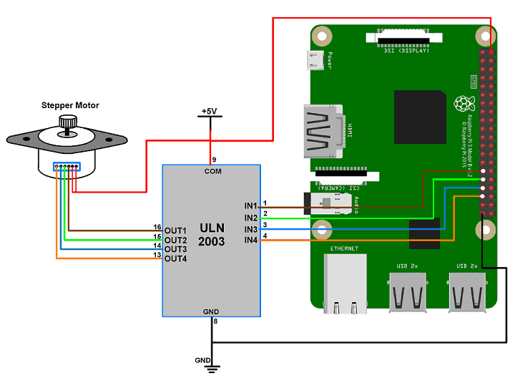

Example
Let’s rotate a Stepper Motor in clockwise and counter-clockwise directions alternately.
- Here, we are using six wire unipolar stepper motor. Only four wires are required to control this stepper motor. The two center tap wires of the stepper motor are connected to 5V supply.
- ULN2003 driver is used to drive unipolar stepper motor.
- We will interface Stepper Motor with Raspberry Pi using Python language. In this program, we have used keyboard key as input for selecting motor rotation direction (i.e. clockwise or anti-clockwise).
Note: To find winding coils and their center tap leads, measure resistance in between the leads. From center leads we will get half the resistance value as compared to resistance between winding ends.

Python Program
'''
Stepper Motor interfacing with Raspberry Pi
http:///www.electronicwings.com
'''
import RPi.GPIO as GPIO
from time import sleep
import sys

#assign GPIO pins for motor
motor_channel = (29,31,33,35)
GPIO.setwarnings(False)
GPIO.setmode(GPIO.BOARD)
#for defining more than 1 GPIO channel as input/output use
GPIO.setup(motor_channel, GPIO.OUT)

motor_direction = input('select motor direction a=anticlockwise, c=clockwise: ')
while True:
try:
if(motor_direction == 'c'):
print('motor running clockwise\n')
GPIO.output(motor_channel, (GPIO.HIGH,GPIO.LOW,GPIO.LOW,GPIO.HIGH))
sleep(0.02)
GPIO.output(motor_channel, (GPIO.HIGH,GPIO.HIGH,GPIO.LOW,GPIO.LOW))
sleep(0.02)
GPIO.output(motor_channel, (GPIO.LOW,GPIO.HIGH,GPIO.HIGH,GPIO.LOW))
sleep(0.02)
GPIO.output(motor_channel, (GPIO.LOW,GPIO.LOW,GPIO.HIGH,GPIO.HIGH))
sleep(0.02)

elif(motor_direction == 'a'):
print('motor running anti-clockwise\n')
GPIO.output(motor_channel, (GPIO.HIGH,GPIO.LOW,GPIO.LOW,GPIO.HIGH))
sleep(0.02)
GPIO.output(motor_channel, (GPIO.LOW,GPIO.LOW,GPIO.HIGH,GPIO.HIGH))
sleep(0.02)
GPIO.output(motor_channel, (GPIO.LOW,GPIO.HIGH,GPIO.HIGH,GPIO.LOW))
sleep(0.02)
GPIO.output(motor_channel, (GPIO.HIGH,GPIO.HIGH,GPIO.LOW,GPIO.LOW))
sleep(0.02)

#press ctrl+c for keyboard interrupt
except KeyboardInterrupt:
#query for setting motor direction or exit
motor_direction = input('select motor direction a=anticlockwise, c=clockwise or q=exit: ')
#check for exit
if(motor_direction == 'q'):
print('motor stopped')
sys.exit(0)

